WALT do long multiplication.
3 days of learning start at mild and become super confident before moving onto hot. Once you have done the worksheet move onto creating your own sums.
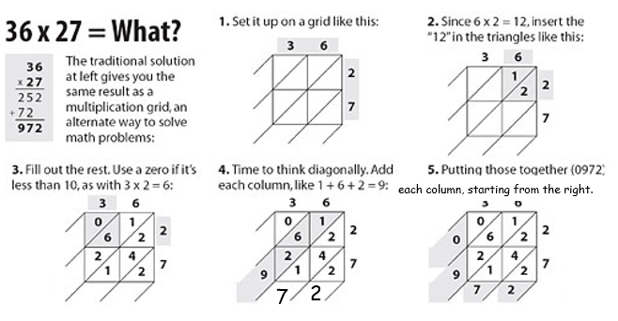
WILF | Self | Teacher
I have rolled the die and got a Mild/hot/spicy number
I have used one square per number
I have used a ruler to draw my grid
I have accurately used my times tables knowledge
I have started to add from the right diagonal, adding my extra 1 into the diagonal in the left
I have got my answer by writing the numbers left to right.
How I feel about using the lattice method for long
multiplication is:
