WALT plan our own scary story. Friday 22nd January 2021
Story Mountain for: _____________________________________________
Problem
________________________________________________________________________________________________________________________________________
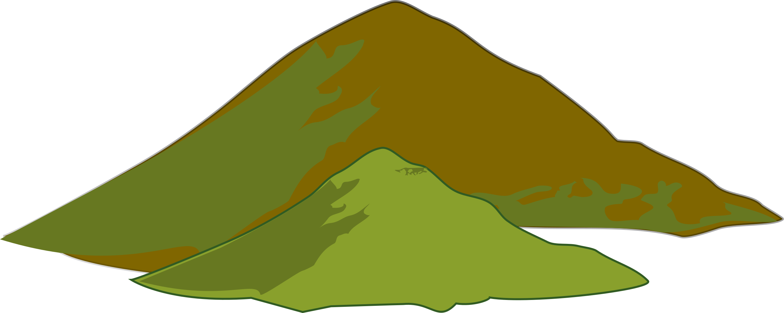
Sentence Styles I have used:
Build Up
________________________________________________________________________________________________________________________________________
Characters

Settings

Resolution
________________________________________________________________________________________________________________________________________
Ending
________________________________________________________________________________________________________________________________________
Introduction
________________________________________________________________________________________________________________________________________

