Maths Home Learning: Year 1 – 3d Shapes and Number Week Commencing Wed 11th Jan 2021
Please write the date and WALT in your book and complete each day.
There are links to games/videos that might support both parents and children.
Some of these activities may need adult support however other tasks can be completed independently. Please make a comment on how much your child was supported in each activity.
NOTE: You do not have to print the resources, your child can copy the worksheet into their books or you can print it for them to work on.
NUMBOTS: https://play.numbots.com/#/game/game-mode MATHLETICS: https://login.mathletics.com

Monday 11th Jan  WALT: understand numbers 11 to 20  Starter Spend 5 minutes learning a times table of your choice (2’s/5’s/10’s) using one of the games/activities shown on page 2.  Activity: Scan the QR code or link on the link to watch a video  Numbers 11 to 20 (2nd video) https://whiterosemaths.com/homelearning/year-1/week-11-number-place-value-within-20/  Activity2: Answer the questions on page 4  Challenge: See page 4 | Tuesday 12th Jan  WALT: Understand tens and ones  Starter Log into NUMBOTS using your Mathletics log in. Begin on ‘story mode’ on the ‘Rust’ level. Spend 10 minutes working through the activities  Activity: Scan the QR code or link on the link to watch a video  Tens and ones (3rd video) https://whiterosemaths.com/homelearning/year-1/week-11-number-place-value-within-20/  Activity 2: Answer questions on page 5  Challenge: See page 5
Wednesday 13th Jan  WALT: Count one more and one less  Starter Log into Mathletics and complete some number and place value to 50 activities.  Activity: Scan the QR code or link on the link to watch a video  Count one more one less (5th video) https://whiterosemaths.com/homelearning/year-1/week-11-number-place-value-within-20/  Activity 2: Answer questions on page 6  Challenge: See page 6  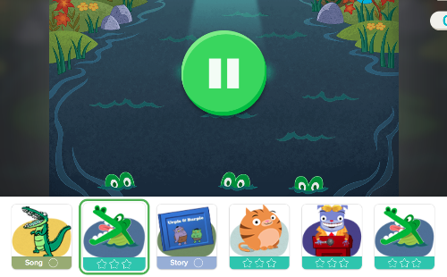  Play this game: https://www.topmarks.co.uk/learning-to-count/chopper-squad  (Ignore this picture it’s for Thursday’s lesson) | Thursday 14th Jan  WALT: Compare numbers  Starter Log into NUMBOTS using your Mathletics log in. Begin on ‘story mode’ on the ‘Rust’ level. Spend 10 minutes working through the activities  Activity: Scan the QR code or link on the link to watch a video  Compare numbers (2nd video) https://whiterosemaths.com/homelearning/year-1/week-12-number-place-value-within-20/  Activity 2: Scan the QR code or link on the link to watch a video https://www.youtube.com/watch?v=M6Efzu2slaI  Activity 3: Scan the QR code or clink on the link to play these two games – it’s quick and free to sign up for maths games, however, if you don’t wish to do this then answer questions on page 7  https://www.education.com/game/less-than-greater-than/ Alligator swamp  Rolly cat (leave the alligator game then at the bottom of the game is a picture of a cat  Challenge: See page 7
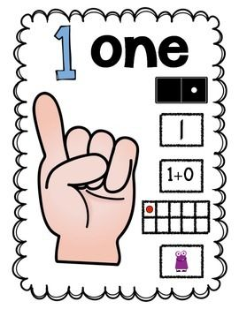
Friday 15th Jan

Please spend 20 -30 minutes playing maths games – on Numbots and Mathletics, counting objects around your home (pasta, Lego, toys, pens…)
make a number poster (see pic), give a challenge – build a lego model using 10 red blocks, 4 yellow blocks, 15 white blocks and 7 blue blocks
Exploring TopMarks games: Click on the link or scan the QR code https://www.topmarks.co.uk/maths-games/5-7-years/counting
Write numbers outside – using water on pavement, chalks, sticks, and leaves…
Go outside to play maths games – counting whilst playing catch/passing a ball (what’s one more one less)
Hopscotch
Be creative and have fun! Take a picture and email your teacher – we’d love to see!

Times Table Learning Menu
Focus on your 2’s, 5’s and 10 timetables.

Ask someone to write a times table fact but miss out some of the numbers. Can you identify the missing numbers? | Play a game of ‘snap’ by matching times tables facts to the correct answers. | Practise counting  in multiples of a given times table while throwing and catching a ball. If the ball is dropped, you must start from the beginning.
Choose a times table and colour in the multiples on a hundred square. | Create some times tables question cards for your chosen table. Place the cards face down. Each player turns over one card and answers the question. The person with the highest value answer wins a point. | Create a poster of your times tables facts using bubble lettering.
Can you teach a family member your chosen times table? | Say your chosen table our loud while jogging/jumping or hopping on the spot. | Draw a scribble in your book and see how many times table facts you can fit inside the scribble.
Try singing your times tables facts to the tune of your favourite song. | Get creative and turn your times table facts into a fun rhyme or rap. | How many times can you write your chosen times tables facts in 45 seconds?

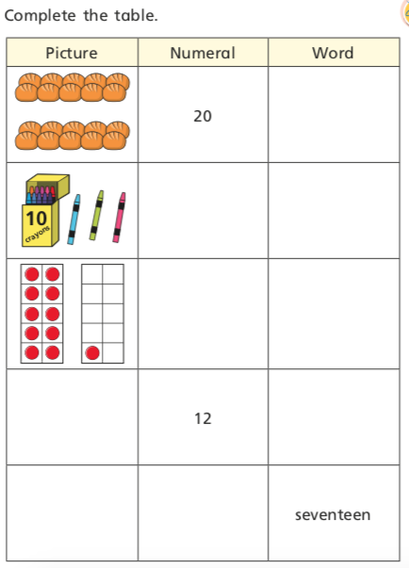

Date: 11.01.21
WALT: understand numbers 11 to 20
I can… | say number
 | say how many tens and one in number
 | draw and write number

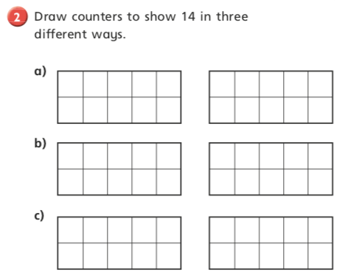

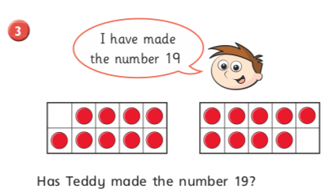

Challenge: Explain your answer to someone in your home

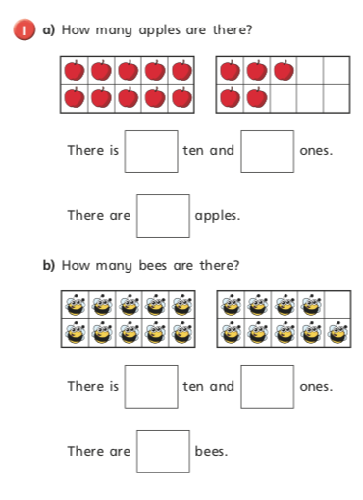

Date: 12.01.21
WALT: understand numbers 11 to 20
I can… | say number
 | say how many tens and one in number
 | draw and write number

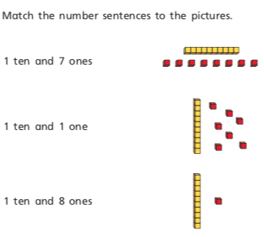
2)

Challenge: Complete the questions below
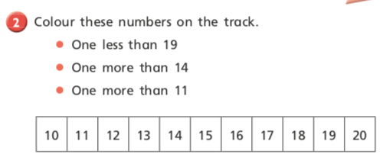

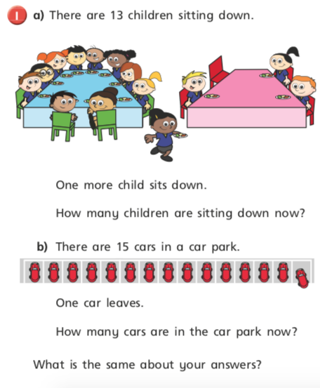

Date: 13.01.21
WALT: Count one more and one less
I can… | say number
 | say one more and one less
 | write new number

Challenge: Answer the questions below
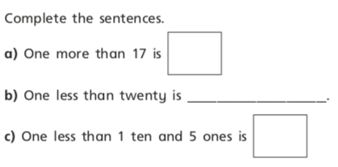

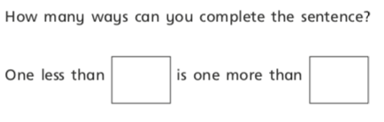

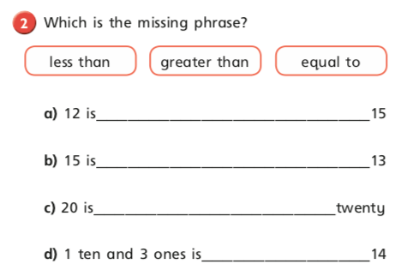

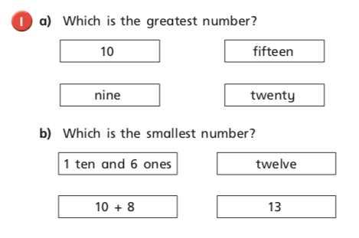

Date: 13.01.21
WALT: Compare numbers
I can… | say number
 | understand greater and less than a number
 | use greater than and less than symbols

